**PF Lab NO: 05**

**Name: Ali Rooman**

**Roll No: 24K-0792**

**1. Write a program that checks if a year is a leap year using the modulus operator.**

|  |
| --- |
| #include <stdio.h>  int main() {  int year;  printf("Enter a year: ");  scanf("%d", &year);  if (year % 4 == 0) {  if (year % 100 == 0) {  if (year % 400 == 0) {  printf("%d is a leap year.\n", year);  } else {  printf("%d is not a leap year.\n", year);  }  } else {  printf("%d is a leap year.\n", year);  }  } else {  printf("%d is not a leap year.\n", year);  }  return 0;  } |

**Output**

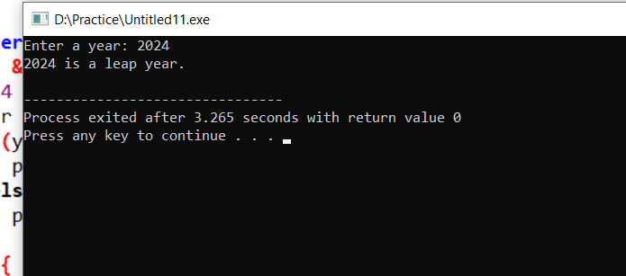

**2. Create a program that calculates the sum of digits of a number until the result is a single digit.**

|  |
| --- |
| #include <stdio.h>  int main() {  int num, sum, digit;  printf("Enter a number: ");  scanf("%d", &num);  sum = 0;  if (num != 0) {  digit = num % 10;  sum += digit;  num = num / 10;  if (num != 0) {  digit = num % 10;  sum += digit;  num = num / 10;  if (num != 0) {  digit = num % 10;  sum += digit;  num = num / 10;  if (num != 0) {  digit = num % 10;  sum += digit;  }  }  }  }  if (sum >= 10) {  int temp_sum = 0;  digit = sum % 10;  temp_sum += digit;  sum = sum / 10;  if (sum != 0) {  digit = sum % 10;  temp_sum += digit;  }  sum = temp_sum;  }  printf("The single-digit sum is: %d\n", sum);  return 0;  } |

**Output**

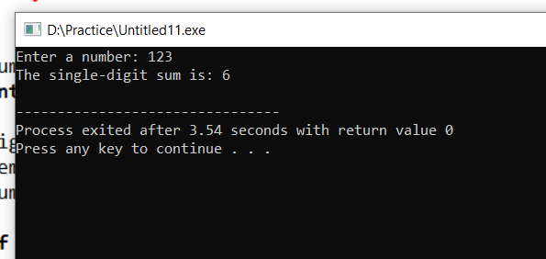

**3. Write a program to find the greatest of three numbers using nested if-else statements.**

|  |
| --- |
| #include <stdio.h>  int main() {  int num1, num2, num3;  printf("Enter three numbers: ");  scanf("%d %d %d", &num1, &num2, &num3);  if (num1 >= num2) {  if (num1 >= num3) {  printf("The greatest number is: %d\n", num1);  } else {  printf("The greatest number is: %d\n", num3);  }  } else {  if (num2 >= num3) {  printf("The greatest number is: %d\n", num2);  } else {  printf("The greatest number is: %d\n", num3);  }  }  return 0;  } |

**Output**

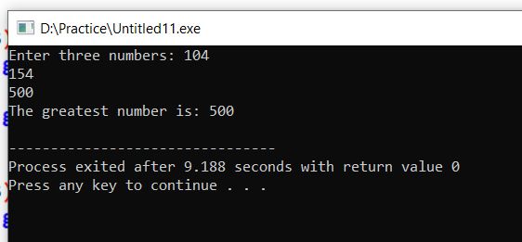

**4. Create a program that calculates the final grade of a student based on multiple criteria, including attendance, assignment scores, and exam results, using nested decision structures.**

|  |
| --- |
| #include <stdio.h>  int main() {  int attendance;  float assignmentScore, examScore, finalGrade;  printf("Enter attendance percentage (0-100): ");  scanf("%d", &attendance);  if (attendance >= 75) {  printf("Enter assignment score (out of 100): ");  scanf("%f", &assignmentScore);  printf("Enter exam score (out of 100): ");  scanf("%f", &examScore);  finalGrade = (0.3 * assignmentScore) + (0.7 * examScore);  if (finalGrade >= 90) {  printf("Final Grade: %.2f (A)\n", finalGrade);  } else if (finalGrade >= 80) {  printf("Final Grade: %.2f (B)\n", finalGrade);  } else if (finalGrade >= 70) {  printf("Final Grade: %.2f (C)\n", finalGrade);  } else if (finalGrade >= 60) {  printf("Final Grade: %.2f (D)\n", finalGrade);  } else {  printf("Final Grade: %.2f (F)\n", finalGrade);  }  } else {  printf("Attendance is below the required 75%%. Student is ineligible for grading.\n");  }  return 0;  } |

**Output**

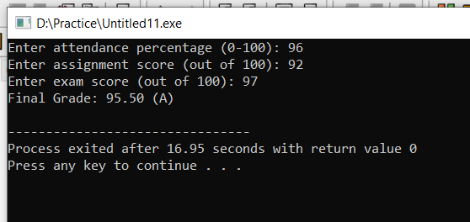

**5. Develop a program that uses logical operators to determine if a person is eligible for a loan based on age, income, and credit score.**

|  |
| --- |
| #include <stdio.h>  int main() {  int age;  float income;  int creditScore;  printf("Enter your age: ");  scanf("%d", &age);  printf("Enter your annual income: ");  scanf("%f", &income);  printf("Enter your credit score: ");  scanf("%d", &creditScore);  if (age >= 18 && income >= 30000 && creditScore >= 650) {  printf("You are eligible for the loan.\n");  } else {  printf("You are not eligible for the loan.\n");  if (age < 18) {  printf("Reason: You must be at least 18 years old.\n");  }  if (income < 30000) {  printf("Reason: Your income must be at least $30,000.\n");  }  if (creditScore < 650) {  printf("Reason: Your credit score must be at least 650.\n");  }  }  return 0;  } |

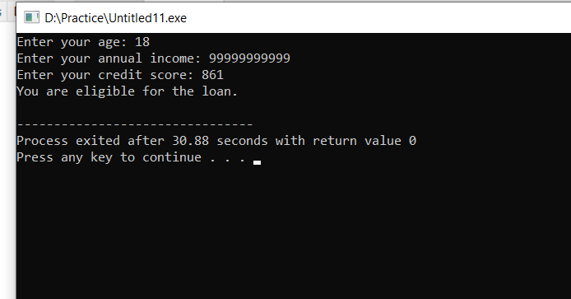**Output**